Project Design Phase-II Technology Stack (Architecture & Stack)

|  |  |
| --- | --- |
| Date | 14 October 2022 |
| Team ID | PNT2022TMID34253 |
| Project Name | Project - Skill / Job Recommender  Application |
| Maximum Marks | 4 Marks |

# Technical Architecture:

The Deliverable shall include the architectural diagram as below and the information as per the table1 & table 2

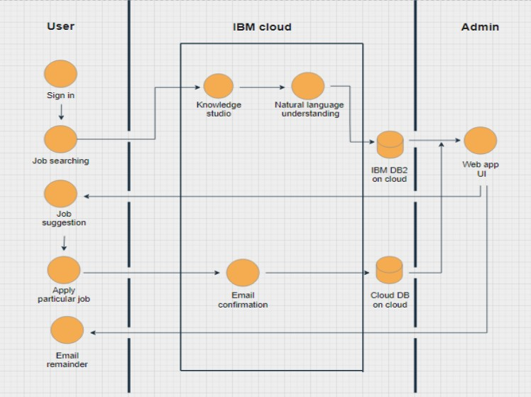

# Table-1 : Components & Technologies:

|  |  |  |  |
| --- | --- | --- | --- |
| **S.No** | **Component** | **Description** | **Technology** |
| 1. | User Interface | WEB UI | HTML5, CSS3,SASS,Bootstrap5,  JavaScript. |
| 2. | Application Logic-1 | Logic for a process in the application | Python Flask |
| 3. | Application Logic-2 | Logic for a process in the application | Send Grid service |
| 4. | Application Logic-3 | Logic for a process in the application | IBM Watson Assistant |
| 5. | Database | Data Type, Configurations etc. | MySql, PL/SQL |
| 6. | Cloud Database | Database Service on Cloud | IBM DB2 |
| 7. | File Storage | File storage requirements | IBM Bucket |
| 8. | External API-1 | To fetch the job details and post in the web UI | Indeed API, CarrerJet API |
| 9. | External API-2 | Purpose of External API used in the application | None |
| 10. | Infrastructure (Server / Cloud) | Application Deployment on Local System / Cloud Local Server Configuration: Docker  Cloud Server Configuration: Kubernetes | Docker, Kubernetes |
|  |  |  |  |

**Table-2: Application Characteristics:**

|  |  |  |  |
| --- | --- | --- | --- |
| **S.No** | **Characteristics** | **Description** | **Technology** |
| 1. | Open-Source Frameworks | List the open-source frameworks used | Bootstrap5, Flask |
| 2. | Security Implementations | List all the security / access controls implemented,  use of firewalls etc. | HTTPS |

|  |  |  |  |
| --- | --- | --- | --- |
| **S.No** | **Characteristics** | **Description** | **Technology** |
| 3. | Scalable Architecture | Justify the scalability of architecture (3 – tier, Micro-services) | Micro Service |
| 4. | Availability | Justify the availability of application (e.g. use of  load balancers, distributed servers etc.) | The load balancer is all handled by IBM |
| 5. | Performance | Design consideration for the performance of the application (number of requests per sec, use of Cache, use of CDN’s) etc. | IBM free tier, Cache is maintained for 15 days |